Utilization of sewage sludge from wastewater treatment process for energy recovery
Vivek Patil
Department of Biosystems Engineering
Abstract
The ultimate residual product of secondary treatment of wastewater from agricultural and biological systems is the solid sewage sludge. The conventional method to get rid of this waste is by landfill, dumping or incineration. However, recovery of energy in the form of solid, liquid and gaseous fuels from this sludge can reduce the load on landfills as well as generate revenue from this under-utilized biomass resource. This paper will aim at evaluating the environmental feasibility of fuel generation from sewage sludge. It will also compare various technologies available for energy generation and their suitability for sludge handling. Due to the wet nature of this sludge, additional cost for drying may incur in some of the cases. However, technologies like hydrothermal liquefaction can take wet feed and hence eliminate the need for drying and will be evaluated in detail. The environmental cost of these thermochemical conversion processes will be assessed in terms of total emissions generated from burning of sludge-derived fuels. At the same time, benefits of utilizing this path for utilization of sludge are reduced land/ air pollution from landfills, as well as generation of renewable energy. This can significantly reduce environmental impact of biosystems in regions with large number of agro-processing, poultry, and animal feedstock or food industries
Keywords: Sludge, Hydrothermal liquefaction, organic solvent, Biocrude
- Introduction
The waste water treatment plants produce sludge as the ultimate by-product. Handling of sludge takes 45-65% of the total wastewater treatment plant (WWTP) [1][4-6]. The constituents of sludge are non-fibrous carbohydrates, proteins, fiber, lipids, ash etc. [2]. Typically, this sludge is sent to landfills or incinerated right away[3]. These methods cause secondary pollution and are also expensive due to the energy lost in drying. From the literature, sludge management cost is seen to be varying widely. For example, in the state of California, it is found to be from $5.4 - $89.5/wet ton [7]. There have been instances of using sludge in anaerobic digestion (AD) for generation of energy. The residual biosolids produced in this process can also be used for land applications. But the type of crop is also important factor to be taken into consideration while making this application. Also, there are public concerns about health risks of doing the same [7]. In short, the AD route is not economically attractive yet. Alternatively, hydrothermal liquefaction of the sludge does not need drying of the sludge prior to its use in the reactor. It directly converts wet sludge into fuels and chemicals. Hence, as compared to other costly options for sludge utilization and landfilling which has no added benefit, hydrothermal liquefaction of sewage sludge is an environmentally and economically feasible option.
Sewage sludge from wastewater treatment facility is found to have energy content of ~13.8 MJ/kg on dry mass basis [8]. Research in this area have led to biocrude yields from sludge in the range of 10-45 wt% at 523-673 K, with reaction time between 30-60 min and slower heating rate [9-16]. The recent approach by researchers is to heat the sludge rapidly for a short period of time, which is termed as fast HTL (hydrothermal liquefaction) [17,18]. In the fast HTL, set point temperature is 600°C with 1 min residence time, as compared to 400°C with 60 min residence time for usual HTL. There can be various catalysts utilized for this process, for example alkalis such as K₂CO₃, Na₂CO₃ or organic acids such as formic acid, acetic acid or transition metals, metal oxides such as MoO₃-CoO/Al₂O₃, Ru/C[18].
- Process overview
The basis for developing hydrothermal liquefaction process for sewage sludge is all the previous work done on algae and biomass/lignin liquefaction. Also, bio crude produced from HTL needs to be upgraded in order to be suitable for further use.
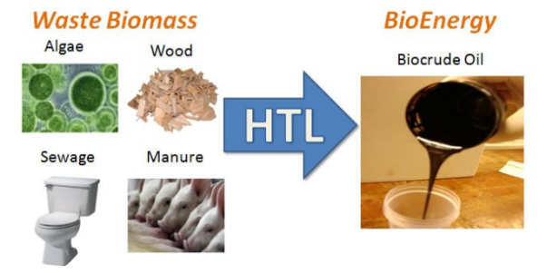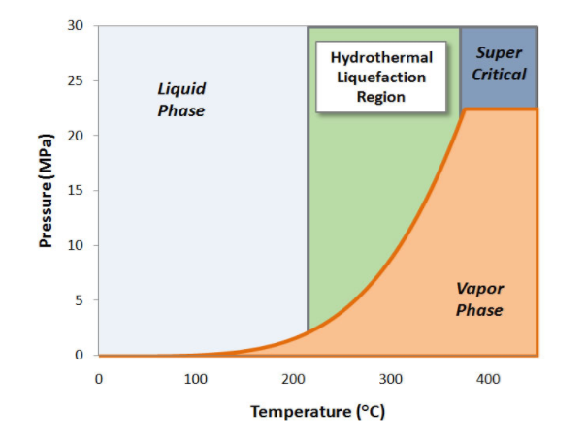
Fig. 1. Hydrothermal liquefaction conditions for water[19]
The illustration on figure 1 shows conditions required to reach the hydrothermal liquefaction region for water. Also, various feedstocks as shown in the figure are converted to black thick biocrude. For the use in WWTP, an HTL plant can be set up right next to it. A centralized upgrading facility can take all the biocrude from various HTL plants and produce hydrocarbon biofuels from it. The products of hydrothermal liquefaction can be broadly classified in three parts: An organic biocrude, an aqueous phase and biochar. The aqueous phase has around 1.25% carbon content. This phase can be subjected to catalytic hydrothermal gasification to recover some energy before discharge. The gases formed are also recovered in some cases. Ash become a part of biochar. The biocrude produced has a significant calorific value. In addition to that, it also contains variety of chemicals as shown in figure 2.
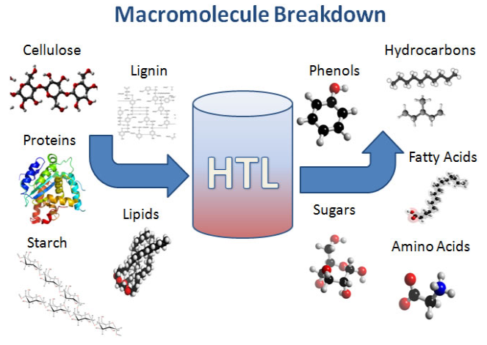
Fig. 2. Breakdown of molecules in sewage sludge into various chemicals via HTL
The biocrude produced can be transported at a cost of $0.1/ gallon gasoline equivalent (gge) [20]. The upgrading of biocrude needs gaseous hydrogen, which can be produced with energy input from natural gas. A design case for sewage sludge is presented by PNNL (Pacific Northwest National Laboratory) and the estimated values are based on design done for algae HTL by Jones et al.(2014) and Knorr et al.(2013) [1,21,22]. The block diagram in figure 3 describes the overall process.
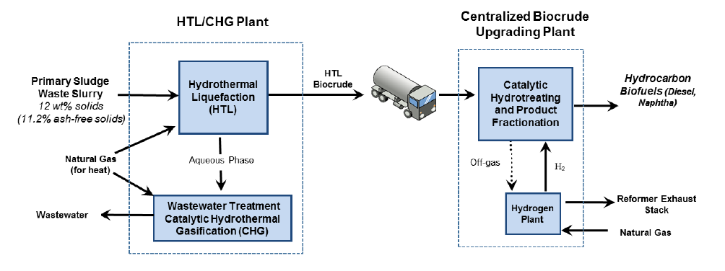
Fig. 3. Block diagram for HTL/CHG/upgrading facilities next to WWTP[1]
The total solids content of raw waste can range from 58 kg/1000kgLW (Beef) to 86 kg/1000kgLW (Dairy). The sludge from WWTP can have total solids depending on type of species in the biosystem.
- Sludge characteristics
The sludge in a WWTP can come from either primary, secondary or tertiary treatments. The tertiary treatment sometimes includes residual biosolids for AD. The primary treatment sludge will be having better properties for HTL and will produce biocrude with higher yield. An example of municipal sewage sludge is presented in figure 4, taken from a study carried out by Annacis Island WWTP in Vancouver, B.C. The class A biosolids produced in this facility met the U.S. EPA guidelines for land application [23].
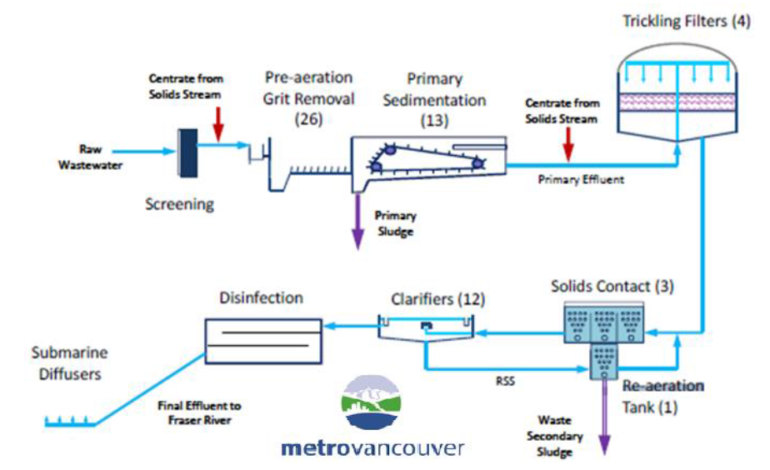
Fig. 4. The locations of generation of primary and secondary sludge in a WWTP [23]
The HTL plant was operating 100 dry ton/day of sludge containing 12% solids. The biocrude produced was sent to an upgrading facility 100 miles away which treated 2020 barrel per stream day of final fuel. $-16.2/wet ton of feedstock credit was received by the HTL plant for treating sludge from WWTP. This scale of plant is only 4% of average gasoline or diesel production scale at refineries [24]. The characteristics of sludge can be better understood from table 1.
Table 1 : CHONS analysis of primary sludge [23]
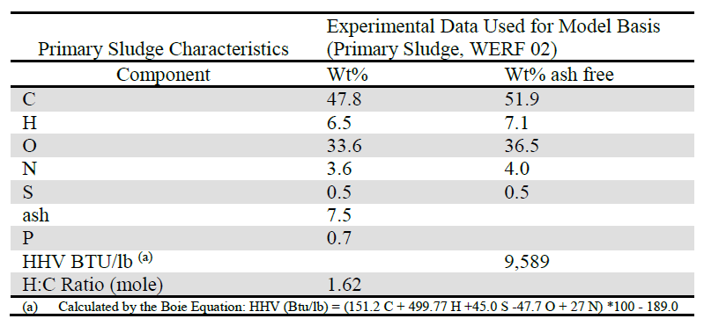
Although HTL process can take waste feed, certain level of dewatering is needed while receiving sludge from WWTP.
- Hydrothermal liquefaction of sludge
A process diagram for the sludge HTL facility shows the flow of energy and materials across the streams.
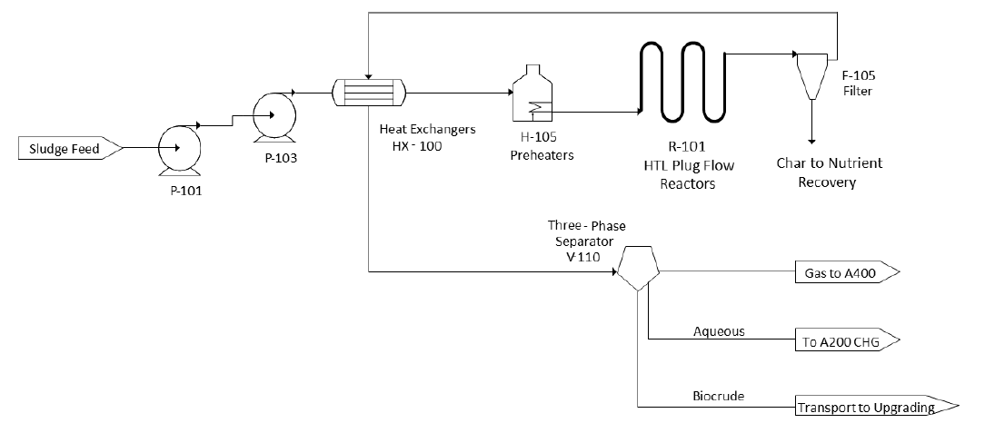
Fig. 5. Process diagram for sludge HTL
As can be seen in figure 5, the sludge is diluted up to 88% water content and pumped to the reactor. Here, it is subjected to 339°C and 20 MPa, which converts it into biocrude. The CHG, off-gas heat and char nutrient recovery aid the process in minimizing the waste. The data in Table 2 gives an overview of results of the process.
Table 2: HTL of primary sludge
Operating parameters | HTL process | Upgrading process
Temperature | 339 °C | 400 °C
Pressure | 20 MPa | 10 MPa
Feed solids | 12% | -
Liquid Hourly Space Velocity | 2.1 vol/vol.of reactor/h | 0.37 wt./wt.of catalyst/h
Residence time | 29 minutes | 31 hours
Products yield, (dry ash free sludge basis)  Biocrude  Aqueous phase  Gases  Solid residue | 40.2 %  34.6 %  21.6 %  3.6 % | 76.7 %  18.2 %  6.4 %  -
Biocrude (oily phase) elemental analysis  C  H  O  N  S  Ash | 75.7 %  10.2 %  8.9 %  4.2 %  0.6 %  0.29 % | 84.6 %  14.2 %  1.2 %  0.04 %  -  -
Organic biocrude moisture content | 10.2 wt% | -
Organic biocrude HHV | 37.6 MJ/kg | -
Aqueous phase COD | 41200 mg/L | -
Organic biocrude yield | 39.8 wt/wt % | 76 wt/wt dry biocrude %

- Upgrading of HTL biocrude from sludge
A schematic representation of upgrading of biocrude from sewage sludge HTL is shown in figure 6. Note that the biocrude produced is very thick and dense substance, which is difficult for handling. Also, the properties of biocrude (both physical and chemical) are not suitable for it to be used as it is in downstream applications. Hence, upgrading the biocrude in a short timeframe after its production is crucial to avoid degradation of it.
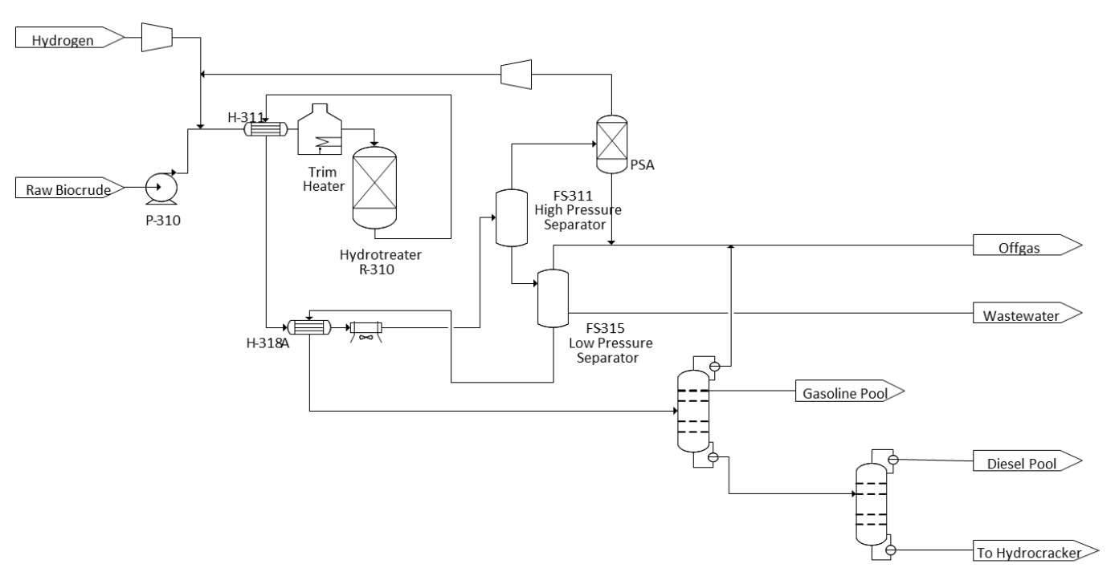
Fig. 6. Process flow diagram for eludge HTL biocrude upgrading
The HTL biocrude supplied to upgrading plant is at 43°C and 1.7 atm. It is then pumped to reactor at 10 MPa and mixed with compressed hydrogen. It is preheated to 400°C before going into the reactor. The upgrading process converts oxygen present in the biocrude to CO₂ and water, nitrogen to ammonia and sulfur to hydrogen sulfide. The hydrocarbons thus received, can be fractionated into different grades, like light oils, naphtha, bio-diesel and heavy oils. An analysis of upgraded biocrude, similar to the one carried out after HTL process is shown in third column of table 2.
Addition of a catalyst is in fact shown to reduce the biocrude yield in almost all the case. Table 4 shows how the yields of different components of sludge hydrothermal liquefaction products change with addition of 10% catalyst [18].
Table 4: Effect of additives on sludge HTL products [18]
Additive (10 wt%) | Biocrude yield (wt%) | Aqueous phase yield (wt%) | Solid residue yield (wt%) | Gas yield (wt%) | Volatiles yield (wt%)
None | 26.8 ± 1.2 | 3.7±0.2 | 14.5±1.1 | 24±0.2 | 31.1
K₂CO₃ | 21.6 ±0.9 | 3.9 ±0.2 | 16.1 ±1.6 | 32.6 ±2.8 | 25.8
Na₂CO₃ | 20.9 | 2.8 | 20.4 | 32.3 | 23.7
HCOOH | 20.7 | 2.8 | 16.2 | 30.5 | 29.8
CH₃COOH | 20.8 | 2.3 | 22.6 | 27.1 | 27
Ru/C | 18.9 | 2.6 | 12.8 | 45.6 | 20.1

The same study also mentions that recovery solvents play a major role in deciding the biocrude yield. The biocrude produced in HTL process is extracted using a solvent, which then is evaporated to get pure biocrude as product. Dichloromethane was found to be the best solvent for this function, giving the maximum heating value as well as material recovery. This study showed that solids loading of 15% is optimum for biocrude yield. This result is in conformity with the earlier results mentioned in this review, which indicated 12% solids loading to be optimum.

6. Comparison of the isothermal HTL with fast HTL
L. Qian et al. (2017) carried out liquefaction of sewage sludge with a novel technology known as fast HTL. Here, the sludge is subjected to a higher temperature (500°C) with a shorter reaction time (1 min). Fig. 7 here shows the comparison of biocrude yield of isothermal (400°C, 60 min) and fast HTL.
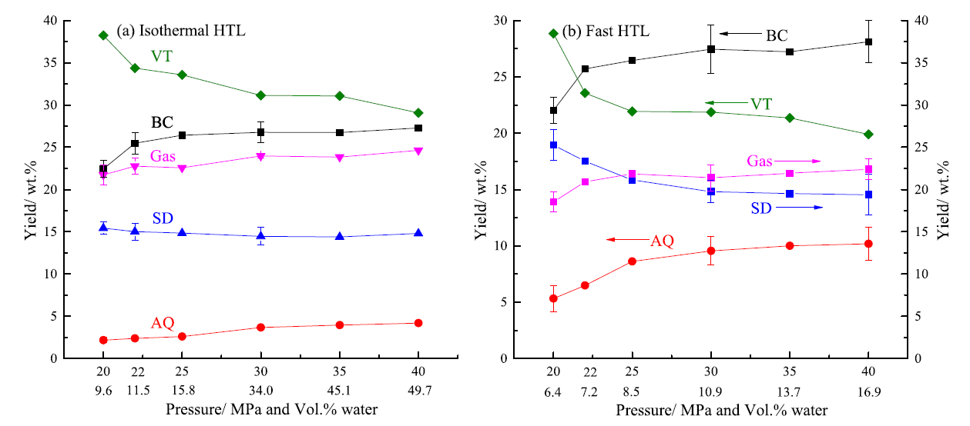
Fig. 7. Comparison of biocrude yield at isothermal and fast conditions [18].
VT: volatiles, SD: solids, AQ: aqueous phase, BC: biocrude
As seen in the figure, higher moisture content as well as operation at higher pressure is seen to increase the biocrude yield. Overall, the yield of biocrude, solids and aqueous phase is higher in the case of fast HTL.

- Economic feasibility of the process
A detailed economic analysis is carried out to calculate minimum fuel selling price (MFSP) of the biocrude produced and to check if the proposed process is economically viable. A discounted cash flow rate of return analysis method is utilized for this purpose. The economic analysis is based on values presented by PNNL lab. The assumptions are made based on various experiments done on sewage sludge and other waste biomass [23][22][19]. It is interesting to note that municipalities pay as much as $125/dry ton for disposal of sludge. Certain technical assumptions are also made, such as an assumption that the pump will be able to operate slurry up to 20% solid content. Other technical parameters, such as biocrude yield, scale of the plant etc. and externalities such as use of CHG, sludge credit etc. will also have a significant impact on the economic analysis. Hence, the values obtained depend greatly on performance of the plant.
There are certain ways to improve the performance of the plants. For example, increasing the feed solids loading rate will reduce the total mass flow to the plant, for constant dry ton/ day of sludge fed into it. This will effectively reduce the overall equipment and hence operating costs. Also, higher solids will lead to higher amount of carbon being reported to biocrude phase during liquefaction process.
Various economic parameters for the hydrothermal liquefaction and biocrude upgrading plants are presented in table 4:
Table 4. Economic Parameters for sludge HTL and upgrading plants
Parameter | Sludge HTL | Biocrude upgrading
Capacity | 92.4 ton/day dry ash-free sludge
Biocrude production | 3 million gallons/year | 573 barrels per stream day  1446 barrels per stream day
Minimum fuel selling price | $3.7/ gallon | $5.3/gal (Diesel)  $4.9/gal (Naphtha)
Capital investment for HTL plant | $37.1 million | $20.9 million
Sludge credit | -$50/ton sludge | -
Internal rate or return | 10% | 10%
Equity % of total investment | 40 % (year 2011) | 40%
Capital cost  HTL  Hydrotreating  Hydrogen plant  CHG  Steam cycle  Plant balance  Total installed capex  Site development  Indirect costs  Working capital  Land  Total capex | $20 million  $9.1 million  $0.6 million  $1.4 million  $31.1 million  $4.4 million  $19.6 million  $2.8 million  - (on site of WWTP)  $57.9 million | $20 million  $17.5 million  $0.9 million  $4.4 million  $42.8 million  $5.2 million  $26.3 million  $3.7 million  $1.5 million  $79.4 million
Manufacturing costs  Yearly plant hours  Feed rate  Sludge feedstock cost  Biocrude feedstock  Natural gas  Catalysts and chemicals  Waste disposal  Electricity and utilities  Fixed costs  Capital depreciation  Average income tax  Average return on investment | 7920  92.4 ton/day  $1.5 million  $0.9 million  $0.9 million  $0.1 million  $0.2 million  $3.4 million  $1.8 million  $1 million  $5.1 million | 7920  32 MMgal/year  -  $123.4 million  $1.6 million  $1.3 million  $0.1 million  $0.8 million  $6.9 million  $2.5 million  $29 million  $185.5 million
Performance  Total electricity usage  Electricity produced onsite  Input energy / Output energy  Carbon efficiency | 371 kW  469 kW  44%  58% (on the basis of sludge) | 1448 kW  1491 kW  -  86 % (on the basis of biocrude)

- Hydrothermal carbonization of sewage sludge
A study carried out by He et al.(2013) explored for production of hydrochars, which are low N and S containing solid fuels. In this process, 88% of carbon was recovered, whereas 60% of S and N was removed. But due to dehydration and decarboxylation reactions, the H/C and O/C ratios reduce to 1.53 and 0.39 respectively. The hydrochars have better combustion properties as compared to raw sludge because of lower activation energy[28].
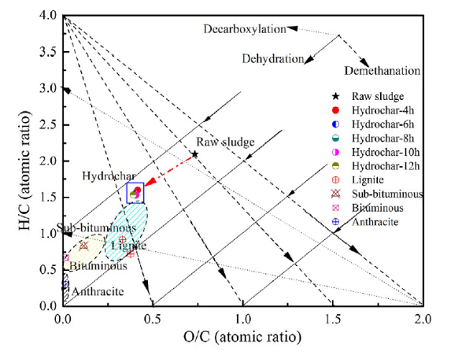
Fig. 8 Van Krevelen diagram for hydrothermal carbonization [28]
A Van Krevelen plot as shown in figure 8 describes the movement of H/C and O/C ratio during hydrothermal carbonization process. It is compared with coal for better understanding. In conclusion, the hydrochar produced at 200°C possessed fuel ratio of 0.18 as compared to 0.02 for raw sludge. Also, the HHV of hydrochar was 0.98-1.03 times that of raw sludge.

- Summary & conclusions
From the technical description and economic analysis, we can see that hydrothermal liquefaction and upgrading of wet sewage sludge from biosystems wastewater is a viable alternative to other conventional methods like anaerobic digestion. The solid sludge is diverted from landfills and hence this process have an environmental benefit. Also, products of HTL and subsequent upgrading can be utilized in production of fuels as well as chemicals, which becomes an added benefit to this process. This biofuel can also be a substitute for diesel or naphtha obtained from non-renewable fossil sources. The economic performance of HTL also helps WWTP reduce their overall expenditure.
There are several areas, which needs advancements and research in technology, such as:
- Economics of HTL plant is largely decided by yield of biocrude from sludge, which in turn depends on optimum process conditions. Maximum yield seen in studies is 45%, which if achieved, can reduce the biocrude price by $0.37/gge. Also, consideration of the amount of primary and secondary sludge streams is beneficial for deciding the optimum conditions.
- Increasing feed solids can enable operating plant at smaller volumes. Considering the biocrude yield of 45%, if we increase the solid loading to 20%, then the biocrude selling price (MFSP) can be reduced by $1.5/gge
- Increasing the liquid hourly space velocity from 2h-1 to 4h-1 can reduce biocrude cost (MFSP) by $0.33/gge.
- Recycling of aqueous phase produced during HTL of sludge can reduce overall biocrude MFSP by $1.2/gge.
- Increasing the biocrude yield to 90% can reduce the biocrude MFSP by $0.58/gge.
(Note: All the reduction in values are with respect to the base case as presented in earlier sections)

References
[1] Pacific Northwest National Laboratory, 2016, “Hydrothermal Liquefaction and Upgrading of Municipal Wastewater Treatment Plant Sludge: A Preliminary Techno-Economic Analysis”, PNNL-25464, Prepared for the U.S. Department of Energy
[2] Suzuki, A., Nakamura, T., Yokoyama, S.-Y., 1990. Effect of operating parameters on thermochemical liquefaction of sewage sludge. J. Chem. Eng. Jpn. 23 (1), 6–11.
[3] Gude, V.G., 2015. Energy positive wastewater treatment and sludge management. Edorium J. Waste Manage. 1, 10–15.
[4] Nowak O.. 2006. “Optimizing the use of sludge treatment facilities at municipal WWTPs.” Journal of Environmental Science and Health Part A, 41(9) 1807-1817.
[5] Gray, N.F. 2010. “Water Technology: An Introduction for Environmental Scientists and Engineers.” Third Edition. Elsevier Ltd., London, UK.
[6] Applied CleanTech. 2014. “Sludge Treatment Costs.” http://www.appliedcleantech.com
[7] SCAP, Southern California Alliance of Publicly Owned Treatment Works (SCAP), “2012 SCAP Biosolids Trends Survey”. 2013.
[8] http://www.sludgefacts.org/Ref87_2.pdf
[9] Inoue, S., Sawayama, S., Dote, Y., Ogi, T., 1997. Behaviour of nitrogen during liquefaction of dewatered sewage sludge. Biomass Bioenergy 12 (6), 473–475.
[10] Malins, K., Kampars, V., Brinks, J., Neibolte, I., Murnieks, R., Kampare, R., 2015. Biooil from thermo-chemical hydro-liquefaction of wet sewage sludge. Bioresour. Technol. 187, 23–29.
[11] Suzuki, A., Nakamura, T., Yokoyama, S.-Y., 1990. Effect of operating parameters on thermochemical liquefaction of sewage sludge. J. Chem. Eng. Jpn. 23 (1), 6–11.
[12] Suzuki, A., Nakamura, T., Yokoyama, S.-Y., Ogi, T., Koguchi, K., 1988. Conversion of sewage sludge to heavy oil by direct thermochemical liquefaction. J. Chem. Eng. Jpn. 21 (3), 288–293.
[13] Yokoyama, S.-Y., Suzuki, A., Murakami, M., Ogi, T., Koguchi, K., Nakamura, E., 1987. Liquid fuel production from sewage sludge by catalytic conversion using sodium carbonate. Fuel 66 (8), 1150–1155
[14] Vardon, D.R., Sharma, B.K., Scott, J., Yu, G., Wang, Z.C., Schideman, L., Zhang, Y.H., Strathmann, T.J., 2011. Chemical properties of biocrude oil from the hydrothermal liquefaction of spirulina algae, swine manure, and digested anaerobic sludge. Bioresour. Technol. 102 (17), 8295–8303
[15] Zhai, Y., Chen, H., Xu, B., Xiang, B., Chen, Z., Li, C., Zeng, G., 2014. Influence of sewage sludge-based activated carbon and temperature on the liquefaction of sewage sludge: yield and composition of bio-oil, immobilization and risk assessment of heavy metals. Bioresour. Technol. 159, 72–79.
[16] Wang, Y., Chen, G., Li, Y., Yan, B., Pan, D., 2013. Experimental study of the bio-oil production from sewage sludge by supercritical conversion process. Waste Manage. 33 (11), 2408–2415.
[17] Faeth, J.L., Valdez, P.J., Savage, P.E., 2013. Fast hydrothermal liquefaction of Nannochloropsis sp. to produce biocrude. Energy Fuels 27 (3), 1391–1398
[18] L. Qian et al., ‘Hydrothermal liquefaction of sewage sludge under isothermal and fast conditions’ Bioresource Technology 232 (2017) 27–34
[19] http://algae.illinois.edu/projects/Hydrothermal.html
[20] Sheppard, David and Bruce Nichols. “Insight: Oil convoy blues: trucking game foils crude traders.” Reuters Technology, Oct. 14, 2011
[21] Jones, S., Y. Zhu, D. Anderson, R. Hallen, D. Elliott, A. Schmidt, K. Albrecht, T. Hart, M. Butcher, C. Drennan, L. Snowden-Swan, R. Davis and C. Kinchin. 2014. “Process Design and Economics for the Conversion of Algal Biomass to Hydrocarbons: Whole Algae Hydrothermal Liquefaction and Upgrading.” Pacific Northwest National Laboratory, Richland, WA. PNNL-23227
[22] Knorr, D., J. Lukas, and P. Schoen. 2013. “Production of Advanced Biofuels via Liquefaction: Hydrothermal Liquefaction Reactor Design.” National Renewable Energy Laboratory, Golden, CO. NRL/SR-5100-60562.
[23] Metro Vancouver, Vancouver, B.C.. 2015. http://www.metrovancouver.org/services/liquid-waste/treatment/treatment-plants/annacis-island/Pages/default.aspx
[24] U.S. Energy Information Administration (EIA). 2016. Petroleum & Other Liquids: Number and Capacity of Petroleum Refineries.
[25] Humbird, David, R. Davis, L. Tao, C. Kinchin, D. Hsu, A. Aden. 2011. “Process Design and Economics for Biochemical Conversion of Lignocellulosic Biomass to Ethanol Dilute-Acid Pretreatment and Enzymatic Hydrolysis of Corn Stover.” NREL/TP-5100-47764, National Renewable Energy Laboratory, Golden, CO.
[26] Mateo-Sagasta, Javier, Liqa Raschid-Sally, and Anne Thebo. 2015. “Global Wastewater and Sludge Production, Treatment and Use.” Book Chapter in “Wastewater: Economic Asset in an Urbanizing World”, P. Drechsel, M. Qadir, and D. Wichelns, Editors., Springer Science_Business Media Dordrecht.
[27] Shammas, Nazih and Lawrence Wang. 2008. “Regulations and Costs of Biosolids Disposal and Reuse.” Book Chapter in “Volume 7 Handbook of Environmental Engineering: Biosolids Engineering and Management”, Volume 7, L.K. Wang, N.K. Shammas, and Y. Hung, Editors., Humana Press, a part of Springer Science+Business Media, LLC
[28] Chao He et al., ‘Conversion of sewage sludge to clean solid fuel using hydrothermal carbonization: Hydrochar fuel characteristics and combustion behavior’, Applied Energy 111 (2013) 257–266

